Experiment Syllabus

Procedure

3:30 Class starts
We begin passing out headphones and scantrons
We will introduce the assessment to the subjects stating what they need to do, and explain the Experiment Question that they will need to answer for each of the trials.
There will be a few test questions/examples given to the subjects in the beginning giving them an idea on the scale of the dB ranges in the experimental scale(0 dB, 2dB, 4dB, 6dB, 8dB).

3:35 The experiment will begin
First trial set will be run with half the participants listening on headphones and half on loudspeakers (loudspeakers for participants on the left, and headphones for participants on the right).
2:30 (15 trials, 10 seconds per trial); Approximately 2:30 break will be given between sets.

3:40 First trial of the next “set” will be run with the participants switching their groups from the first trial. **Subjects will need to denote on their scantrons for each set of trials what group they were in for the given questions somewhere on the scantron**
2:30 (15 trials, 10 seconds per trial); Approximately 2:30 break will be given between sets

3:45 For the remainder of the experiment, the procedure outlined will be repeated with participants switching back and forth for as many sets of trials as can be completed within the time frame ending between 4:30-4:35ish The participants will ideally go through each of the 30 trials 4 times (total of 120 trials) with breaks after every 15 trials.

**4:30-4:35ish** Experiment will be complete
Make sure all scantrons and materials (headphones, clipboards, etc.) are collected properly.

THE END

Experiment Question

**Write Experimental Question on the board in the room so that participants can see it as a reference. In addition to this, note that they need to put their name on each scantron(First and Last), labeling/bubbling the proper set #’s and the LSP vs. HP denotion between the sets as they are completed**

What level of boost or cut do you hear?
- 0 dB
- 2 dB
- 4 dB
- 6 dB
- 8 dB
Scantron Directions

Each participant will be given 4 scantrons in total (corresponding to the planned number of the sets of 30 trials that will be run to the participants over the course of the experiment).

Participants will put their name on each scantron (First and Last) as well as bubble in a number pertaining to Set # (1-4) and will notate what medium they are listening to at each set period (LSP vs. HP).

We will either collect each scantron after they complete each set collecting the first scantron before moving to the second set) or we’ll have them put the completed scantrons under their chairs making sure nobody compares answers in future sets.

Channel Strips for Experimental Design

“ When we pan to the right side, Right side Loudspeakers come on and Left side Headphones come on by themselves (channels 2, 4). When we pan to the left side, Left side Loudspeakers come on and Right side Headphones come on by themselves (channels 1, 3) “
Left Side Headphone: 4
Right Side Headphones : 3
Left side Loudspeaker : 1
Right Side Loudspeaker : 2

**Make sure to remind Bulla to make sure we grab the correct headphones from the other room before beginning the experiment.**
Experimental (Room) Design
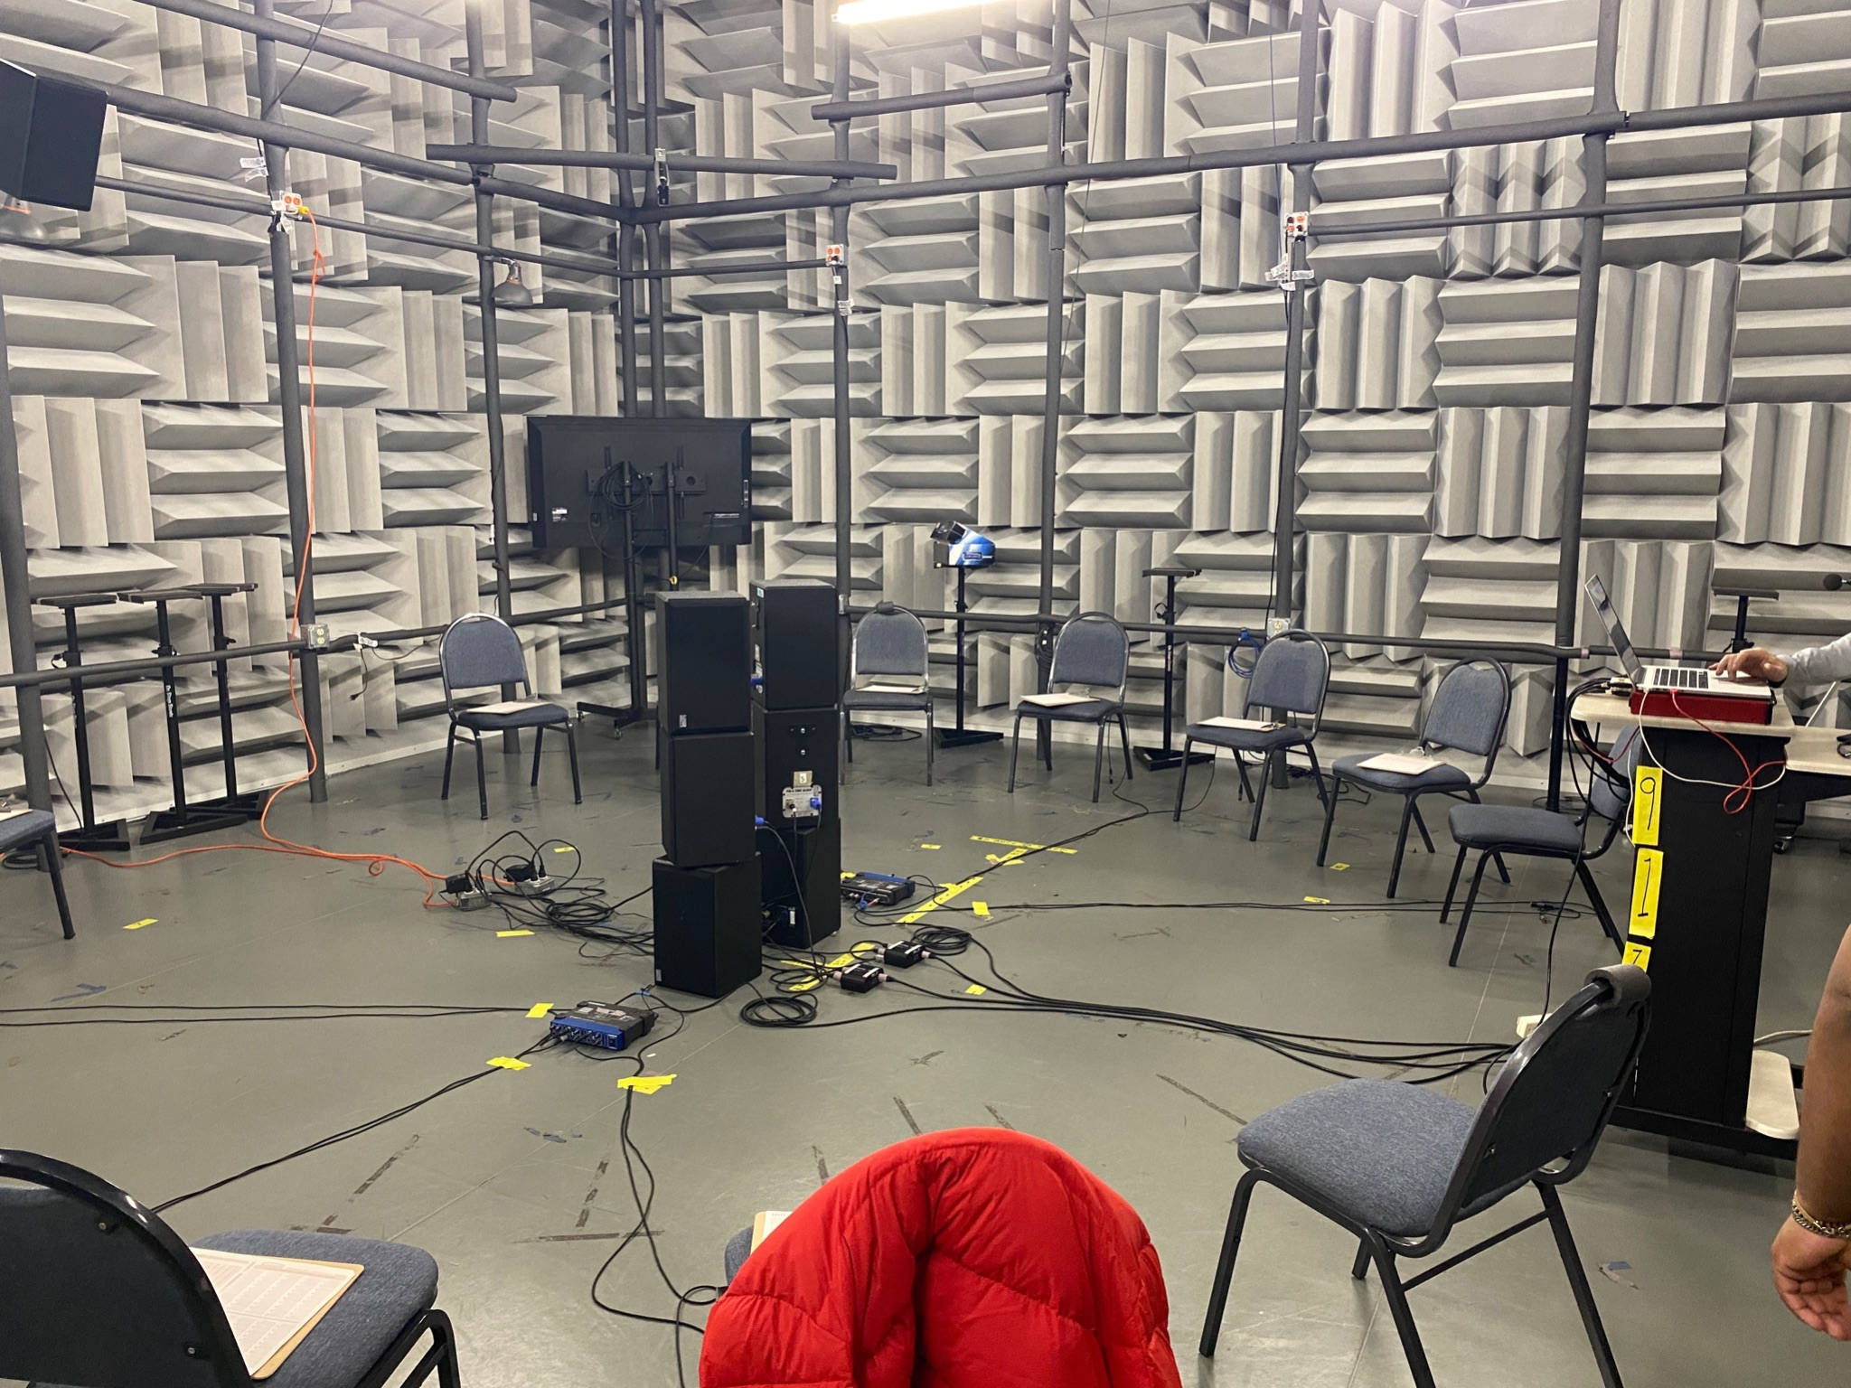

** This is where we can try to figure out how to restate how we set up the space since we’ll probably need that in the final paper part of this. I think it would be worth having a final picture like this taken before the start of the experiment without any participants to be able to include for the presentation and paper part later(this might work, idk). **

The marker with a dB Boost of +6 at 250 Hz was different from the rest.

